附件2

会议论文模板

Title××××××××××××××××××

**Author1, Author *2, Author 3**

1. Tobacco Research Institute, Chinese Academy of Agricultural Sciences, Qingdao, 266101, China

2. …

**A paper from the Proceedings of the International Conference on the Development and Innovation of Modern Efficient Agriculture**

**12-14 August 2025**

**Qingdao, Shandong, China**

***Abstract.***

*International conference on the development and……*

***Keywords.***

*Conference*, *Agriculture,…..*

**Introduction**

Conference….

Agriculture….

**Materials and methods**

**Experimental Design**

Field...

**Statistical analyses**

Agriculture….

**Results**

**Subheading…**

According to…

**Table 1. Vegetation indices….**

|  |  |  |
| --- | --- | --- |
| Vegetation index | Formula | Reference |
| Difference vegetation index (DVI) | NIR-R | Tucker (1979) |
| Modified soil-adjusted vegetation index (MSAVI) | 0.5*[2*NIR+1-SQRT((2*NIR+1)2-8*(NIR-R))] | Qi et al. (1994) |
|  |  |  |

**Subheading…**

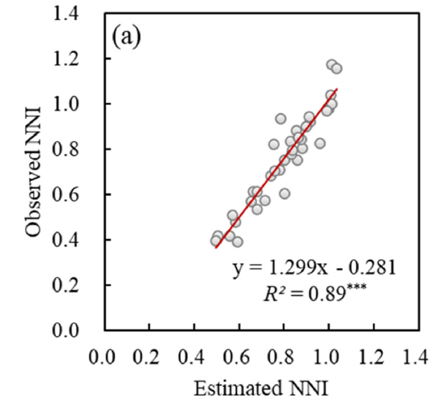

**Fig 1. Relationships …..**

**Conclusions**

Conclusions….

**Acknowledgments**

The….

**References**

Baker, C.J., Sterling, M., Berry, P., (2014). A generalised model of crop lodging. *Journal of Theoretical Biology*, 363, 1-12.